**Personal Portfolio**

Group #73

Thomas Reidy (n9662529)

GitHub: <https://github.com/jakuv/seventy-three>

**Artefact 1** – Registration Mock-up

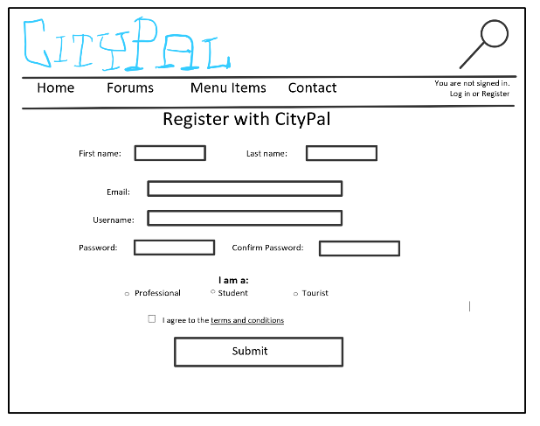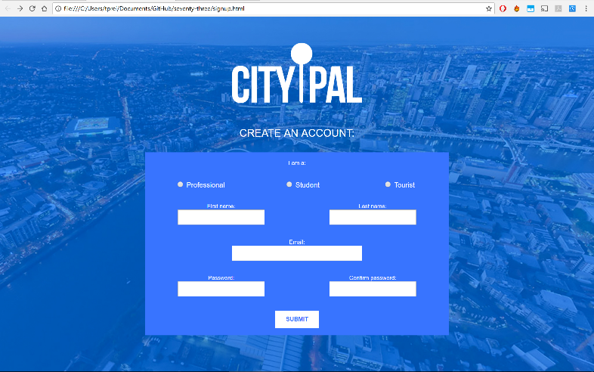

A low fidelity mock-up of the sign-up page, where one would create an account to register with CityPal, was made using OneNote for Surface Pro (left). The general layout of the page was helpful when creating the page and writing the code, which the result is shown on the right, where the structure of the form looks very similar, just the elements are a little bit shuffled around, and there is no ‘username’ field (we later decided to have to user simply log in using their email address). The design of the website matches the rest of the website; the mock-up was created before any design was done.

This artefact is relevant to user stories 1, 2, 3 and 7, as they all relate to creating an account, adding particular details to the account, and selecting which type of account to create (i.e. professional, student or tourist). I believe out of all stories, however, that it most closely is related to user story S02, as it enables to easily create an account, add details, and select which type of account is most suitable.

*See on GitHub:* <https://github.com/jakuv/seventy-three/blob/master/registration-mockup.PNG>

*Also:* <https://github.com/jakuv/seventy-three/blob/master/signup.html>

User Story: S02 - As a user I want to be able to setup a new account, to access content related to my user type.

**Artefact 2** – Data Flow Diagram

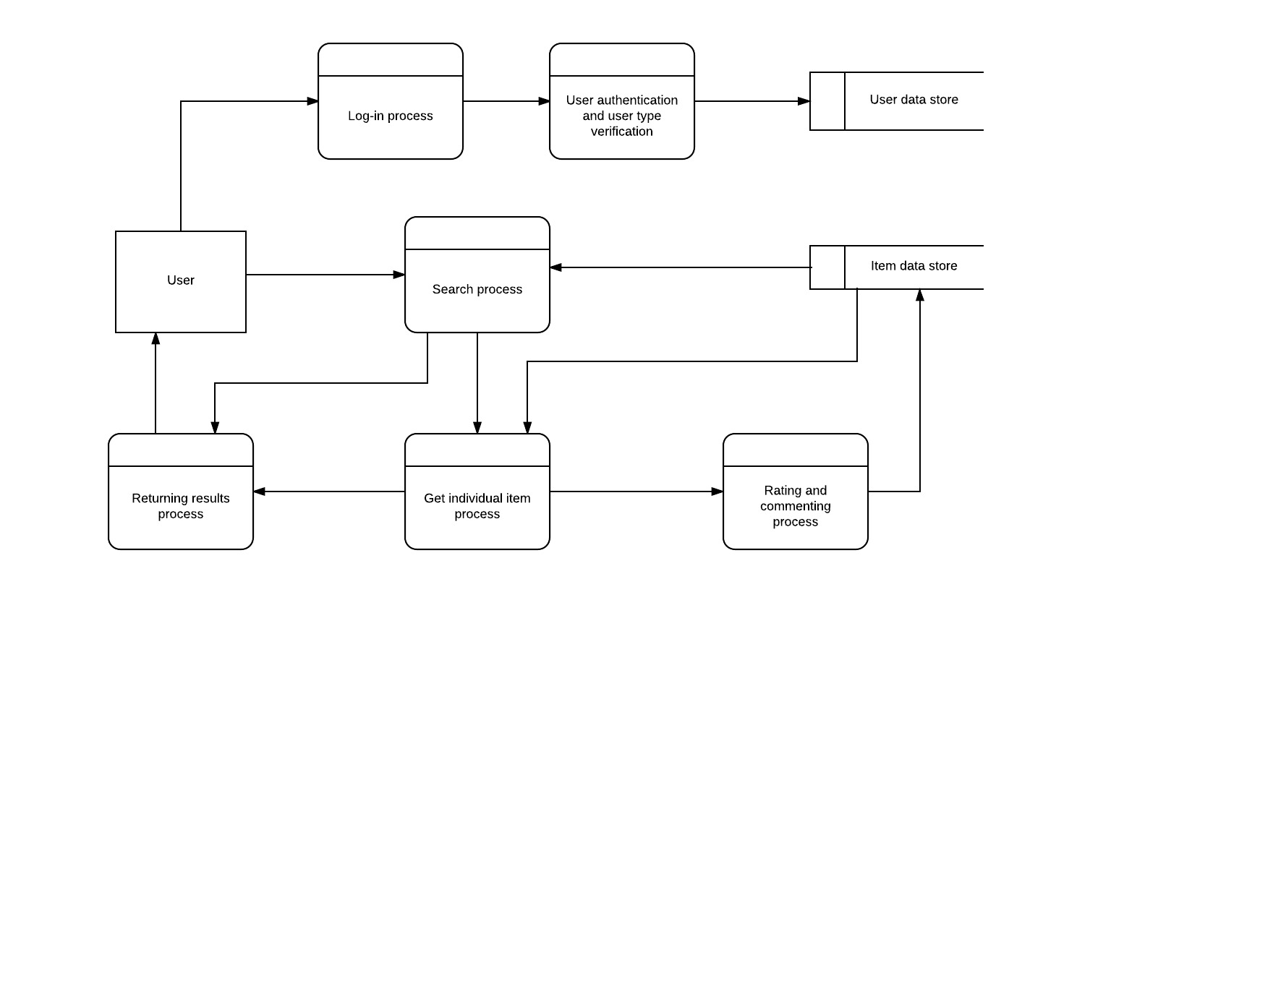

The data flow diagram displays how data flows through CityPal, and where the data is stored. It is used to help develop the website, and how to structure the data flow from different pages, including input and output. It also clearly demonstrates which processes flow to where, as well as where it is stored; ultimately becoming a great aid in developing CityPal.

This artefact is relevant to the majority of user stories, including user registration and logging in. But it is particularly appropriate to those in relation to searching for items, commenting on items, and using the account and CityPal. Hence, I have selected user story ID S17, which states the user wishes to rate available venues based on their experience. The user is logged in, and can get the individual item by searching for it and selecting it from the results page, where the user can then rate and comment on the item. The comment is stored in the database. The user can also view comments left by other users.

*See on GitHub:* <https://github.com/jakuv/seventy-three/blob/master/DataFlow%20Diagram%20-%20Page%201.jpeg>

User Story: S17 - As any user I want to rate available venues based on my experience.

**Artefact 3** – Registration Form Code

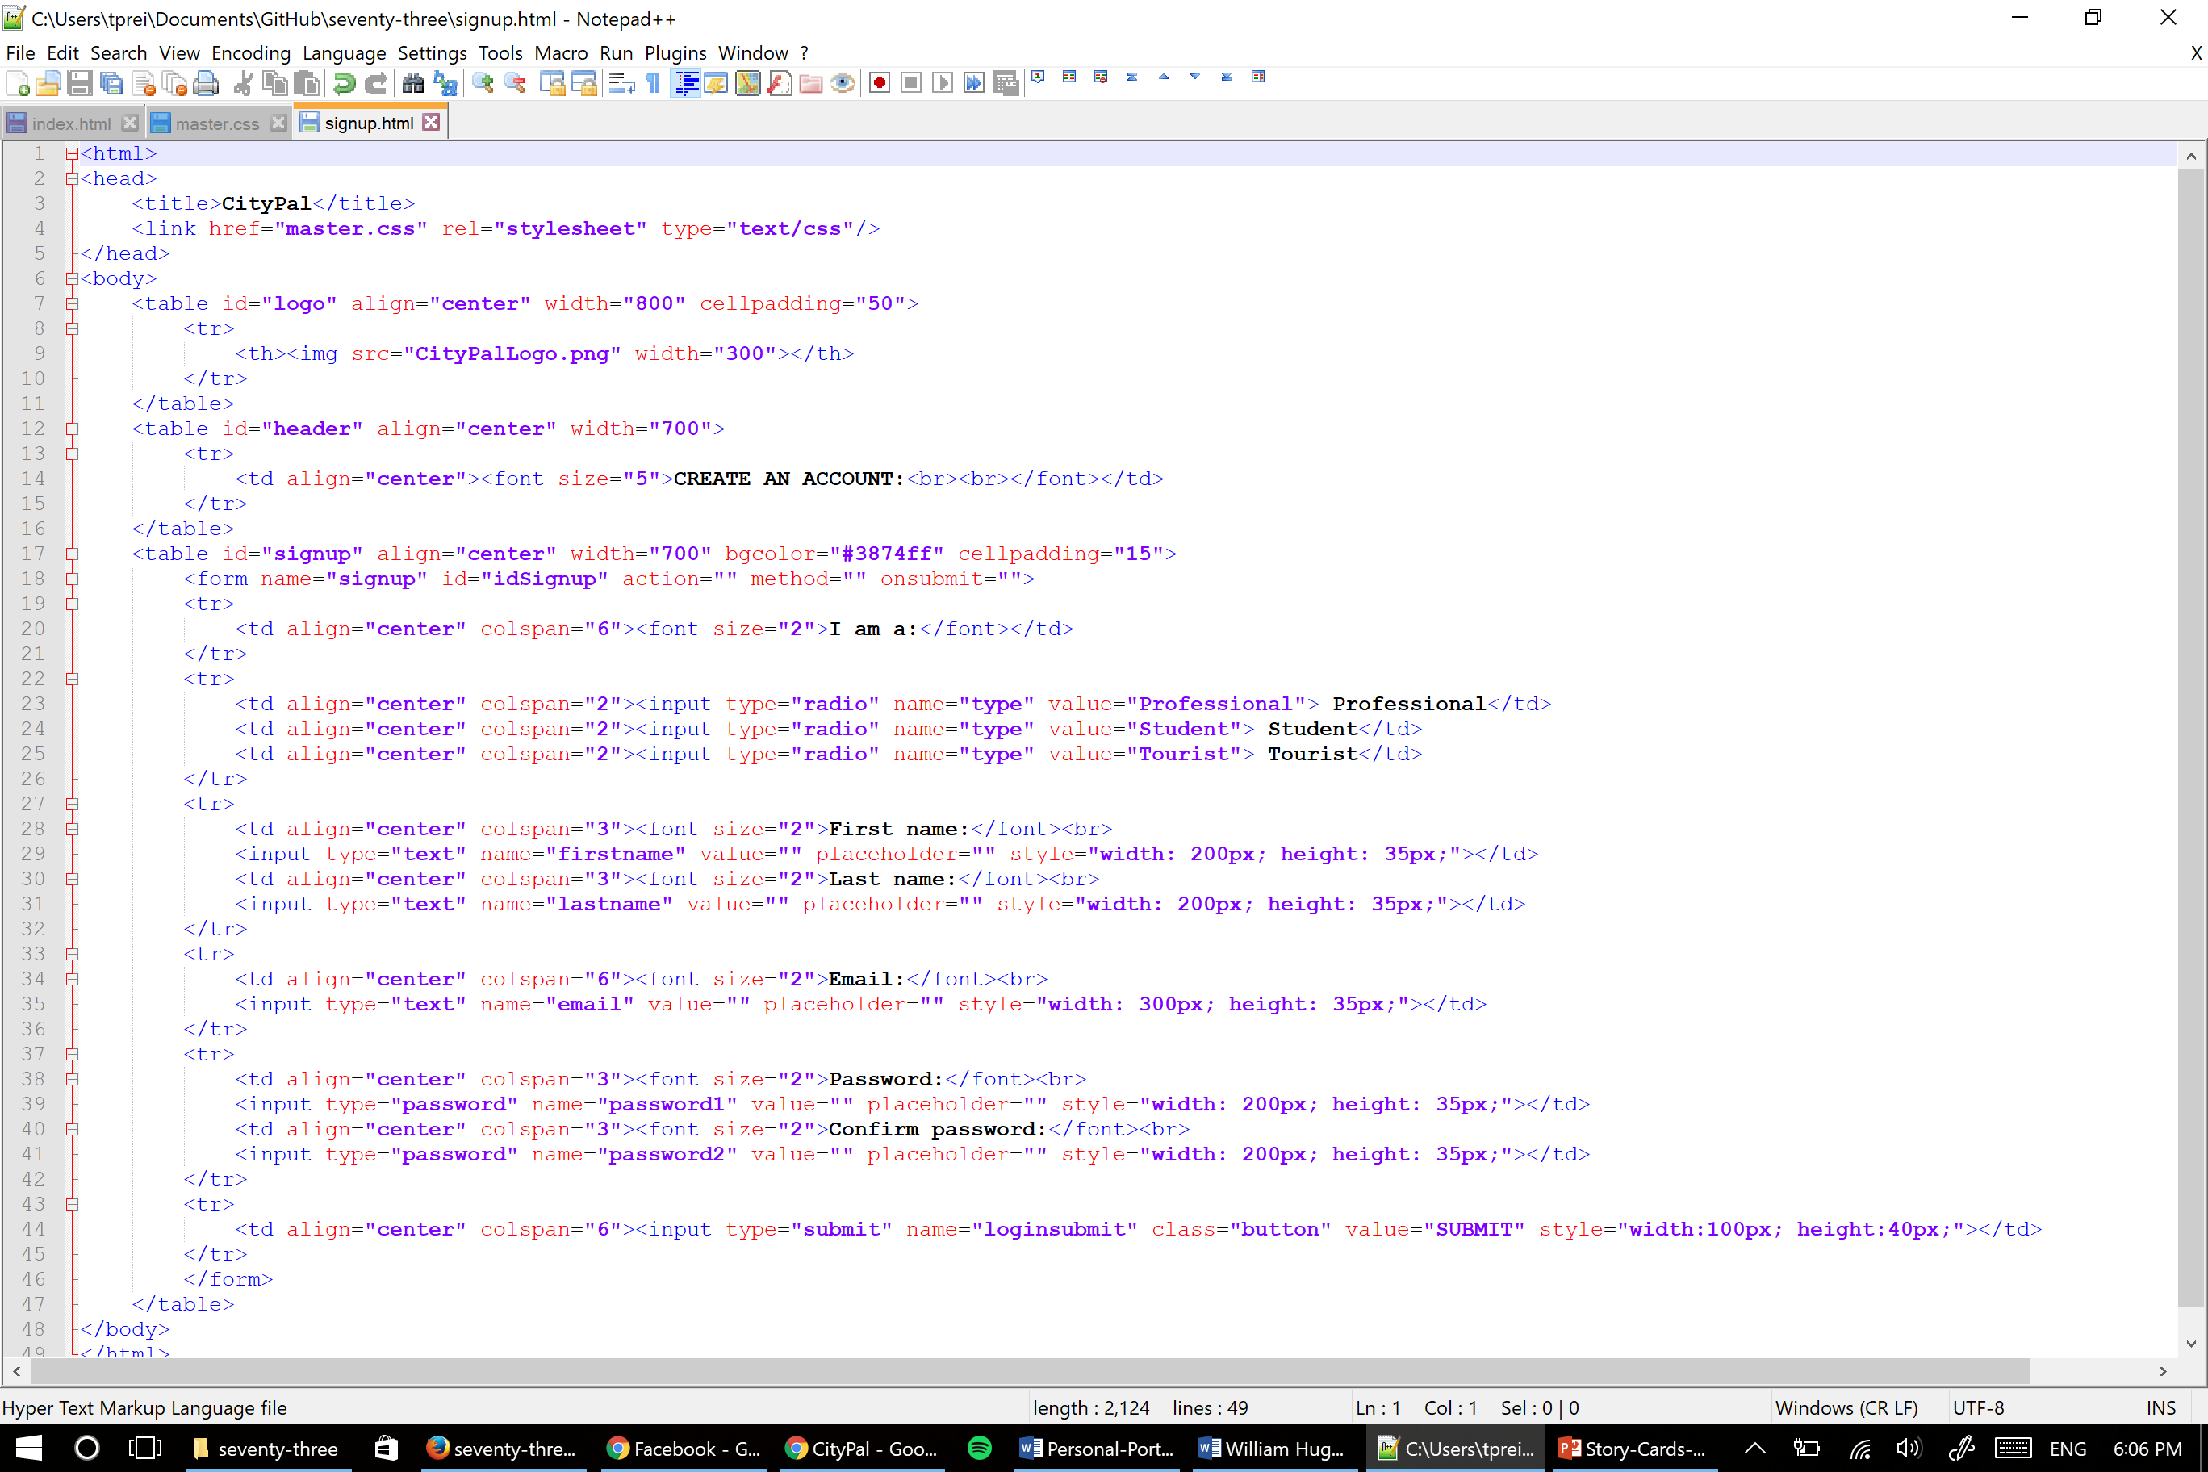

The code is a snippet from signup.html, which displays the sign up/user registration page where users go to create an account for CityPal. It is useful for the project as we will be using it to create users and log them in the database, and users will use their account information to log in and see information relevant to their account type whilst they are using CityPal.

Whilst this relates to user stories 1, 2, 3 and 8, this artefact relates most closely to story ID S02, about account setup. The user wants to be able to register an account. It takes the user’s name and email address, as well as a username.

*See on GitHub:* <https://github.com/jakuv/seventy-three/blob/master/signup.html>

User Story: S02 - As a user I want to be able to setup a new account, to access content related to my user type.

**Artefact 4** – CSS Styling Code

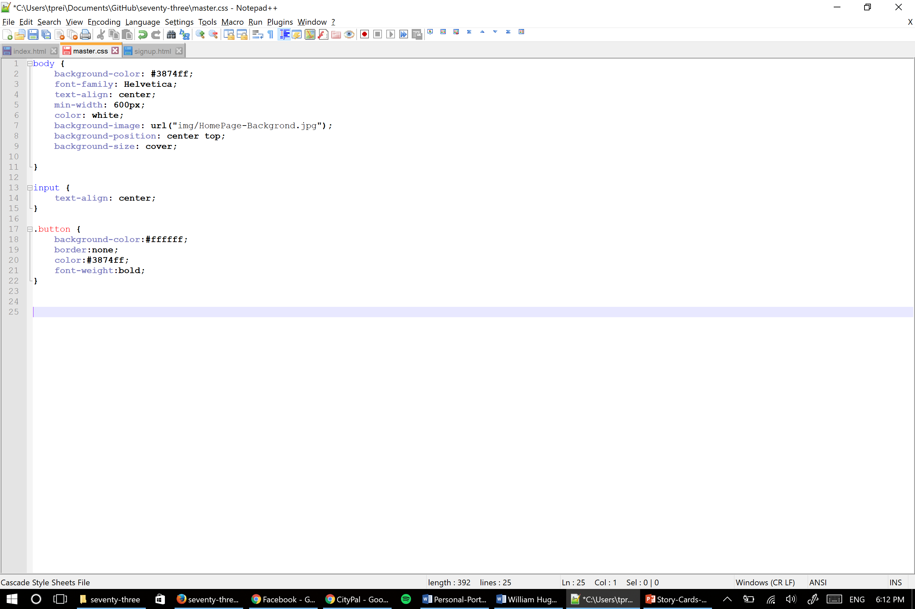

This code is a snippet from the master.css file which is used throughout CityPal. This section, which displays how the body, text input and form buttons are styled, relates to the look and feel of the home page and user registration pages. It is useful for giving CityPal a consistent and simple look and feel.

*See on GitHub:* <https://github.com/jakuv/seventy-three/blob/master/master.css>

User story: N/A.

**Artefact 5** – Home Page/Log in Page Code + Commenting

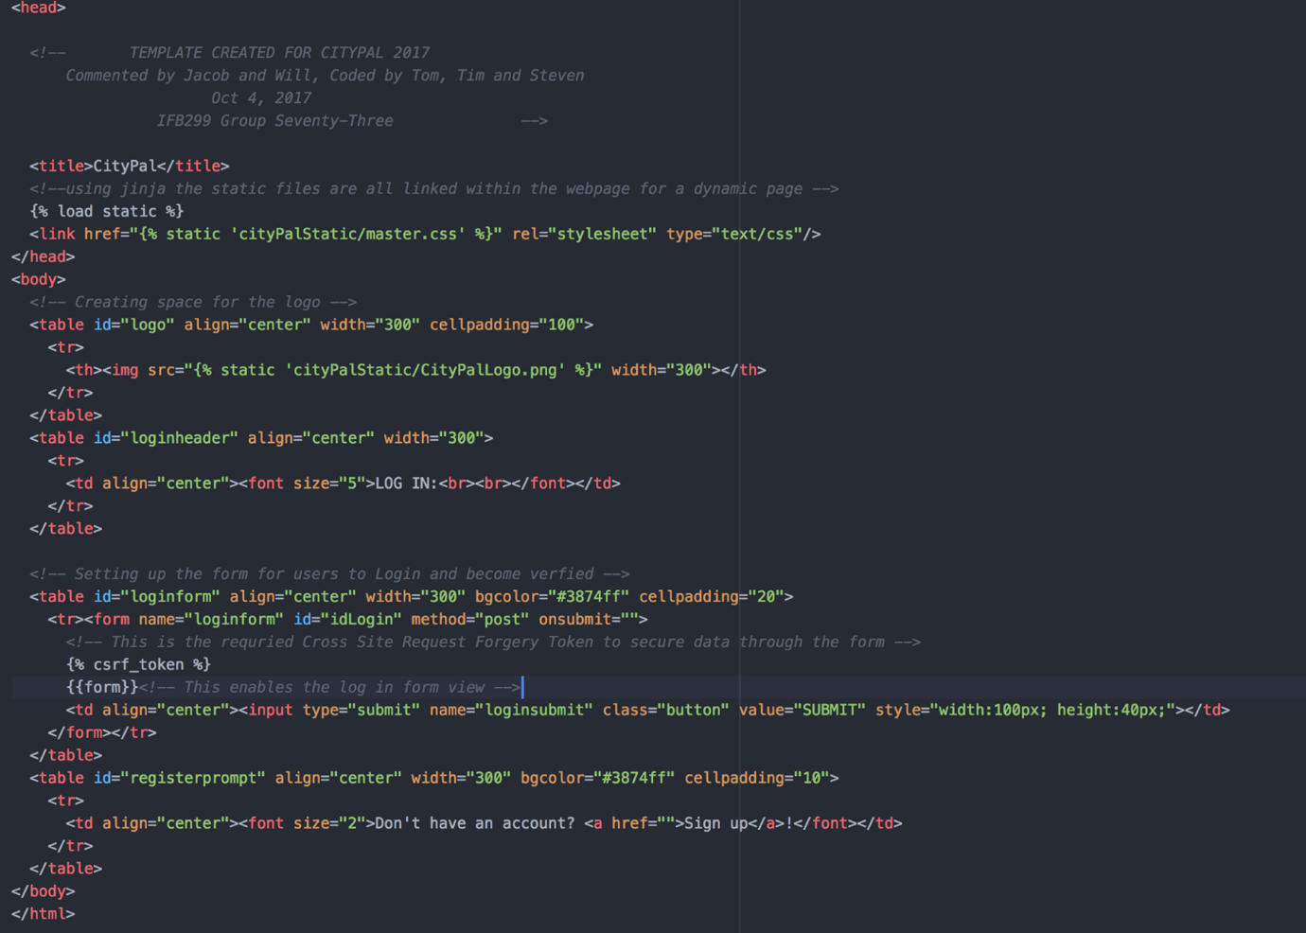

The above code was performed as a team; the CS students together wrote the code, whilst the IS students did the commenting. The code written creates the first page users will see when they go to CityPal, and will be prompted to log in (or to go to the sign-up page). It contributed to the project as it allows users to log in to the website, or to move to create an account with the website, which is one of the aims of the project.

Whilst many of the stories are relevant, it mostly relates to user story S01, as the user is at what is the welcome page of the website. Here, they can log in, or create an account, or simply use the website as is.

*See on GitHub:* <https://github.com/jakuv/seventy-three/blob/master/index.html>

User story: S01 - As a user I want to be able to view the welcome page through a public URL, so that I can perform tasks.